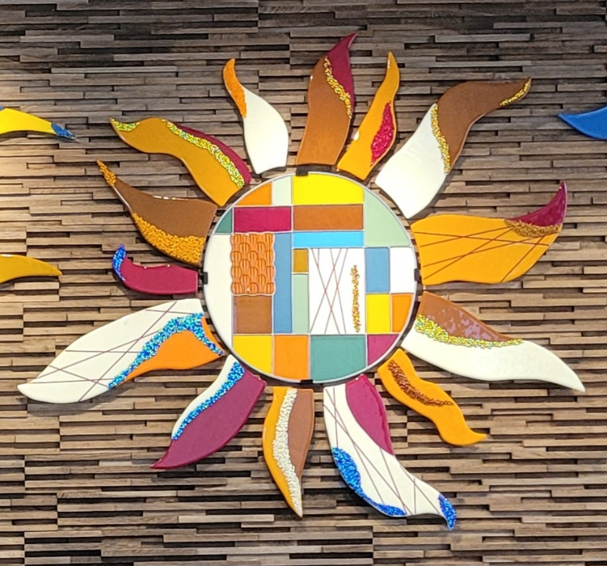

Glass Arts Club
Newsletter

October 2025

An Update

- The Board accepted the resignation of Julie Sribney as club Secretary. A replacement will be appointed before year end. However, keep in mind that elections of club officers will happen in February, so give some thought to serving your club by offering to join the Board in one of the officer positions.

- The studio will be closed on Monday, Ocotober 27th to take inventory of our glass products. It will take at least through the morning and into the early afternoon if necessary. If the work is completed in time, the store will be open until 3pm. This work must be done prior to submitting the next major glass order which should be available for sale by early November.

- The gray box on the wall outside the Glass Arts room is to be used for suggestions and not for any financial transactions. All payments of future membership renewals must be done in person during store hours.

- Exciting classes and instructional demos are scheduled for this month, so check the Education Calendar below and the array of class printouts on the kiln room door.

- Glass pieces continue to be fired as shelves get full enough to fill a kiln. Once more work is put on the shelves, we’ll be able to return to the regular firing schedule.

- Clubhouse renovations are expected to be completed this month. Once the desks are removed from both the hallway outside the Glass Arts room and the atrium, the finishing touches will be done, which includes repainting the trim around the atrium skylight and all the remaining display cases, including ours. Stay tuned for additional updates.

Looking Forward

- November will be a busy month. Here are important dates to note on your calendar:

  - Community EXPO: Thursday, November 6, from 1 to 4pm. Plans are yet to be decided as to where the Arts & Craft clubs will be assigned, but we will have members in the studio working on projects demonstrating what’s involved in making stained or fused glass piece of art. We’ll also be accepting new members, so tell your friends and neighbors to stop by our studio to see the exciting things we do.

  - Glass Arts Club General Meeting: Friday, November 14, from 2 to 4pm. The meeting will be held in the Idylwild+Saddleback rooms across the hall and there will be an Ice Cream Social in the Glass Arts room following the meeting. Plan to attend so that we have a quorum to vote on the business of the February General Meeting and Elections.

  - The Holiday Arts & Craft Show: Friday and Saturday, November 21 & 22, from 9am to 3pm each day. Be sure to let friends, family and neighbors know to come to Mountain View Clubhouse to search for holiday treasures.

Education Calendar for October

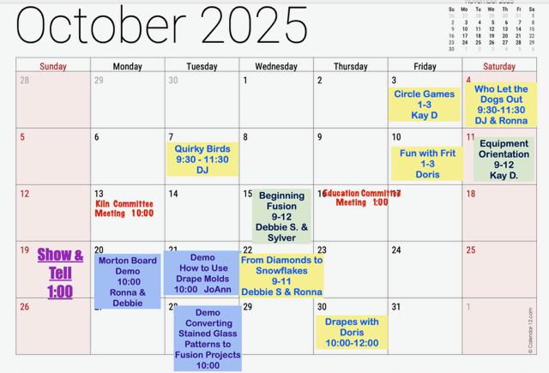

Store Hours for October

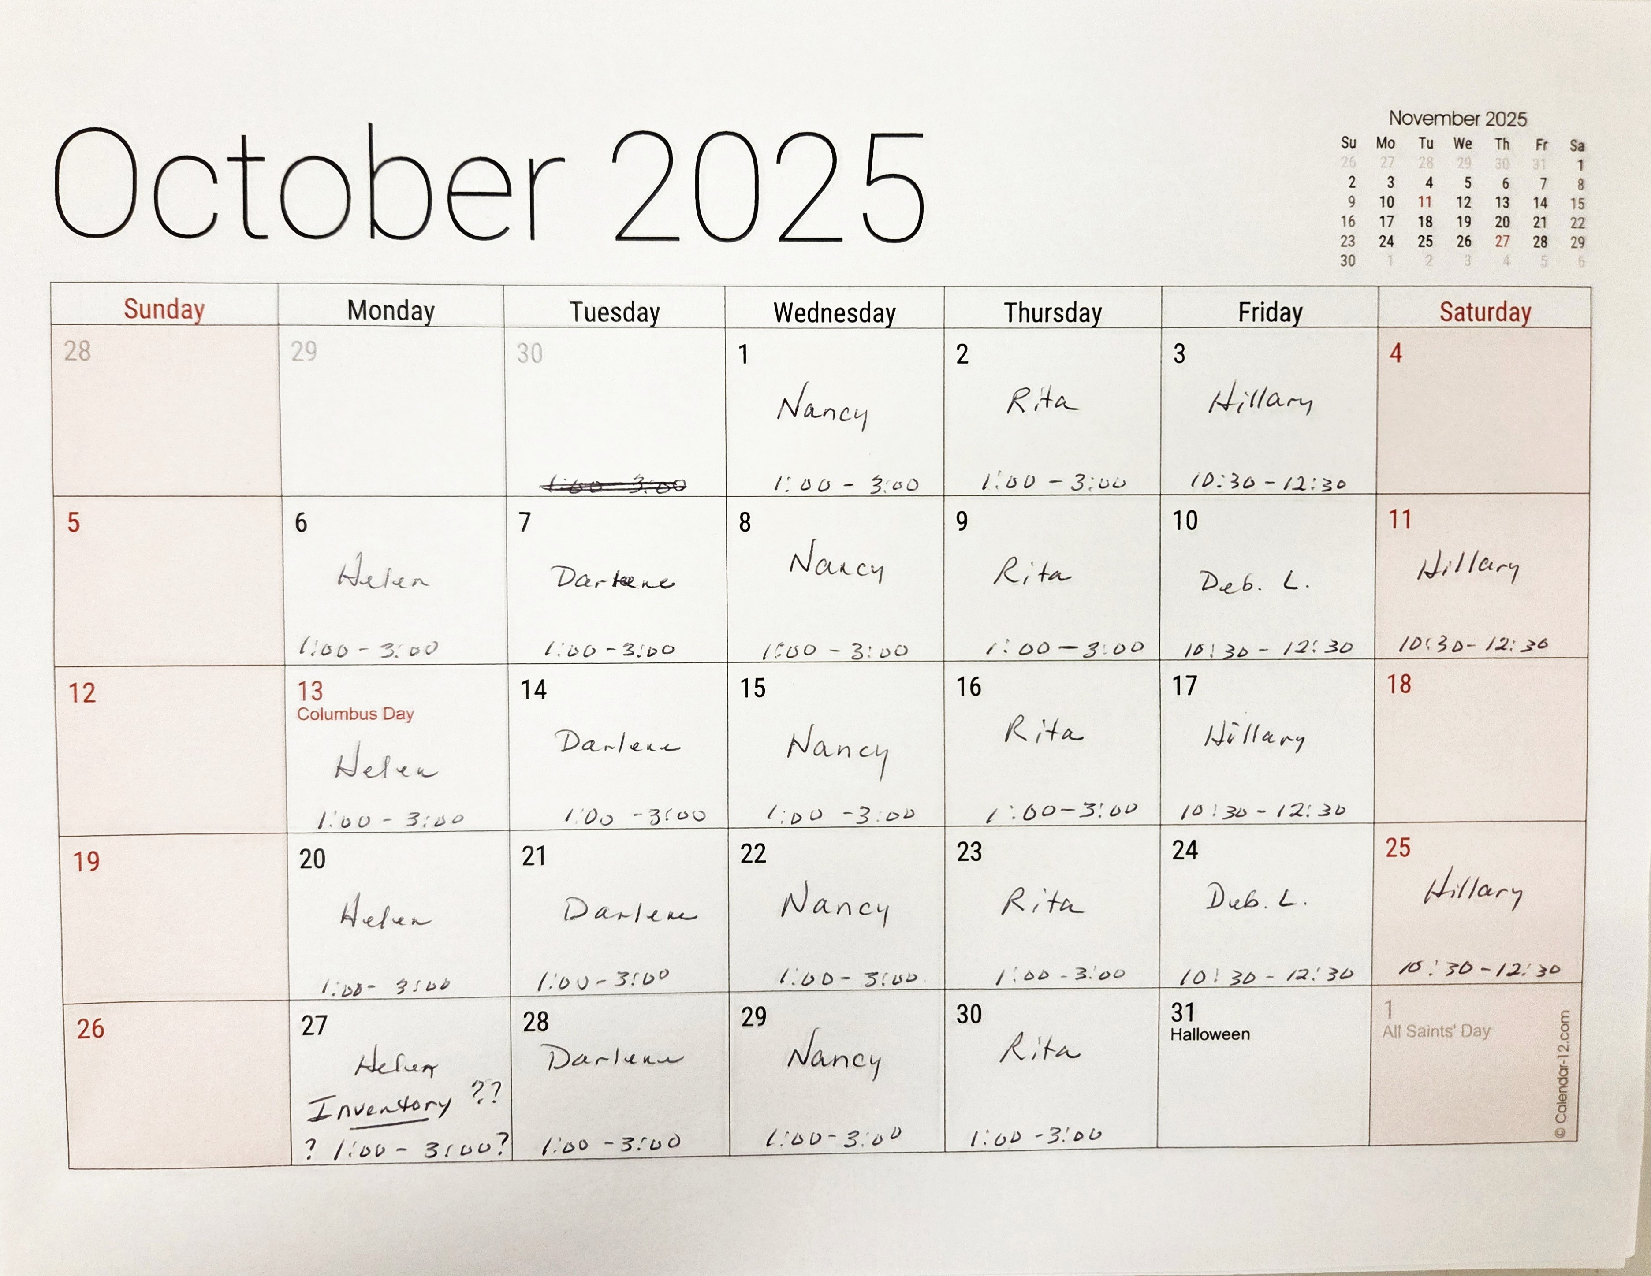

Our Volunteers
Committees
Education Committee Chair: Debbie Lewis -- bryjak24@yahoo.com

Inventory Committee Chair: Julie Sribney – jsribney@gmail.com
Nancy Solomon -- nancysolomon26@gmail.com
Storekeepers: Helen Nielsen – helennielsen@msn.com

Kiln Committee Co-Chairs: NaDean Krasnove – nadeankras@gmail.com &
Liz Young -- iblizy3@aol.com

Display Case: DJ Miles - djmiles1955@gmail.com &
Sylver Kinsella – inkstone2@gmail.com

Library: Diane Boger – diane.boger@gmail.com

News & Views: Carol Bishop – crlbishop9@gmail.com

Safety: Donna Du Fresne – fresnefamily@gmail.com

Social Events: Sylver Kinsella – inkstone2@gmail.com

Arts & Craft Show: Lori Fischer - lorifischer@ymail.com &
JoAnn Effron – joann@effron.com

Webmaster: Sue King – sking0730@gmail.com

Board
President: JoAnn Effron – joann@effron.com

Co-President: Kay Denson – ktraildenson@gmail.com

Vice President: Doug Smith – dsmith@caltech.edu

Secretary: VACANT

Treasurer: Veda Gilman – vedagilman@gmail.com

