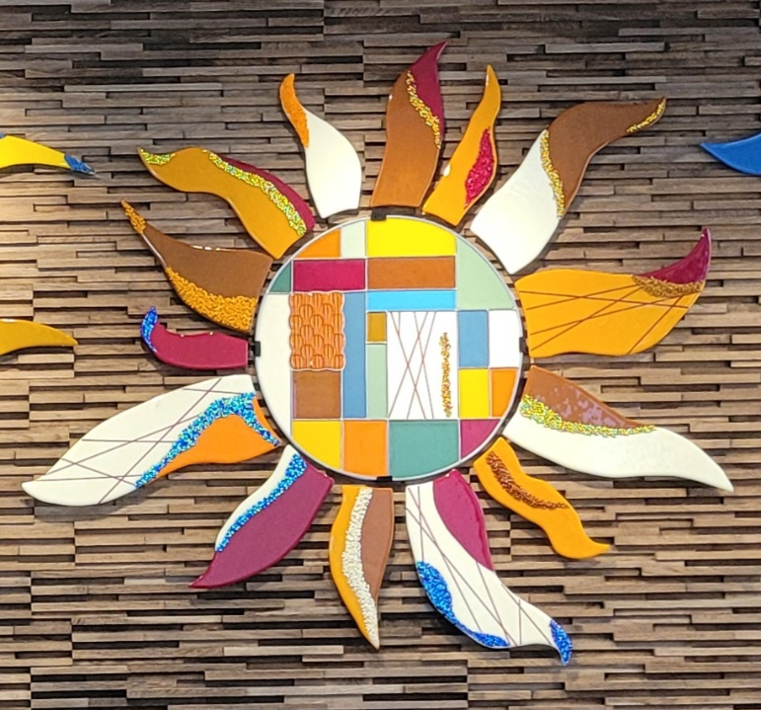

Glass Arts Club
Newsletter

November 2025

Important Dates This Month

- MONDAY, NOVEMBER 3^{RD:} Membership Renewal begins. You’ll need to read the Operating Rules and sign the Acknowledgement Form in addition to paying fees for 2026. Forms and payment must be turned in during store hours.

- TUESDAY, NOVEMBER 4th -- Ornaments for Altadena from 1pm on in the studio: Make holiday ornaments and decorations for Christmas and Hannukah for families in Altadena who lost all in the fires earlier this year. You can also bring in holiday decorations (preferably hand-crafted) to add to the donations. Debbie and Doug Smith will collect everything until November 19th.

- THURSDAY NOVEMBER 6th – EXPO, 1-4pm: We will have members working in the studio and will accept new memberships. JoAnn Effron and Kay Denson will be working at a table in the lobby-ballroom area at Mountain View displaying a variety of the club’s artwork, answering questions about the club and directing potential new members to our room to see the projects being created. There will be no store hours that day.

- FRIDAY, NOVEMBER 14th GENERAL MEETING & ICE CREAM SOCIAL: Enjoy Ice Cream in our studio from 1--2pm and the General Meeting across the hall in the Idyllwild and Saddleback Rooms from 2:15 --4pm. There must be a quorum to address club business, so we need everyone to attend. Sign in and pick up a Membership Form & Operating Rules.

- THURSDAY, NOVEMBER 20TH—Setup for Arts & Craft Show: Studio closed from 1pm on. Remove all work from the Firing shelves by 10:30 am.

- FRIDAY & SATURDAY, NOVEMBER 21st & 22nd -- Arts & Craft Show and Sale, 9am – 3pm daily. Our sellers will have their incredible glass artwork for sale in our room and at small tables in the hallway. Some sellers who are also members of Homecrafters Club will be selling glass at tables located in the open areas of the clubhouse.

- THURSDAY, NOVEMBER 27th -- THANKSGIVING DAY

Greetings from the Firing Squad

November is here and members are back making great projects. Just a few reminders:
- We will be firing by the scheduled type of firing unless there is not enough of that type of projects to fill 2/3 of a kiln. Then the next shelf with the most on it will be fired.
- The firing team will load in the morning each day the studio is open.
- We fire by the order listed in the PURPLE BOOK according to the type for the day. Each member gets one piece and then we go back through the list again for the next piece. If space becomes a problem, we will fire the projects that will fit.
- PLEASE completely list all information on your firing slip.
- Do not put a project on the wire shelves and write it in the PURPLE BOOK until it is ready for firing. Otherwise, it will not be fired.
- The D7 milkshake mold can only be fired in the center of Kiln 2. That means only 1 per slump firing.
- All D7, D5, and votive molds MUST have a paper circle glued to the underside indicating the center placement for the glass being draped.
- If you encounter any issues with a fired project, reach out to NaDean at 310-993-7976 or Liz at 760-409-8181.
- Firing and Cleanup Schedule before and after the Arts & Craft Show:
  - Friday, Nov. 7th-- Recommended last date to submit projects needing two firings before the show
  - Wednesday, Nov. 12th – This is the final day to submit your projects to be fired for the show
  - Wednesday, Nov. 19th - PLEASE PICK UP all fired or not fired projects
  - Thursday, Nov. 20th - ALL PROJECTS MUST BE CLEARED FROM METAL SHELVES by 10:30 am
  - Sunday, Nov. 23rd OR Monday, Nov. 24rd – First Firing after the Arts & Craft Show

HAPPY GLASS PROJECT MAKING!

Education Calendar for November

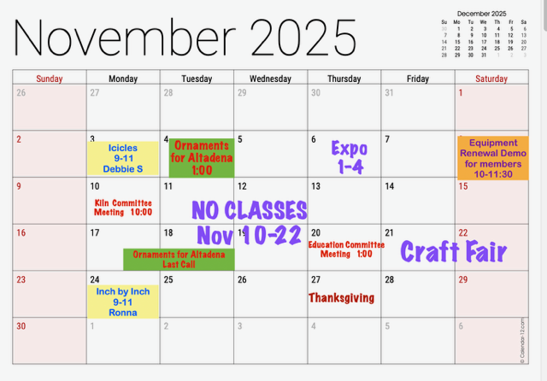

Store Hours for November

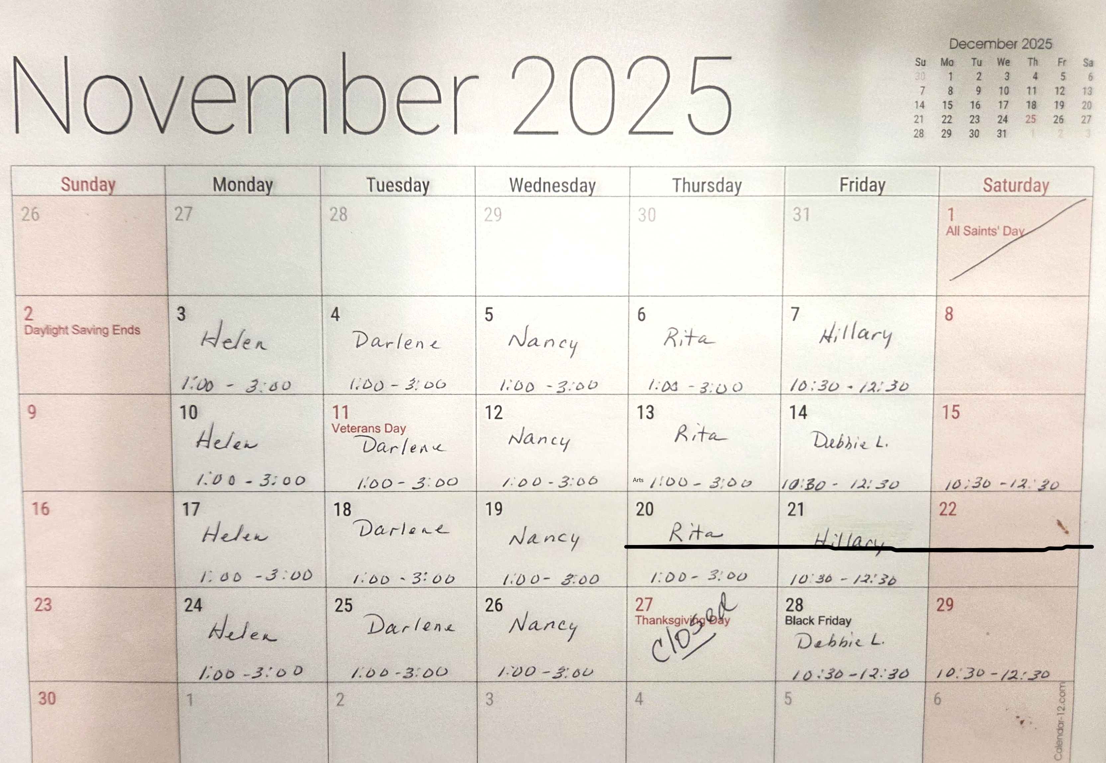

Note that the store will be closed Thursday, November 20th and Friday, November 21st for the Arts & Craft Show.

Our Volunteers
Committees
Education Committee Chair: Debbie Lewis -- bryjak24@yahoo.com

Inventory Committee Chair: Julie Sribney – jsribney@gmail.com
Nancy Solomon -- nancysolomon26@gmail.com
Storekeepers: Helen Nielsen – helennielsen@msn.com

Kiln Committee Co-Chairs: NaDean Krasnove – nadeankras@gmail.com &
Liz Young -- iblizy3@aol.com

Display Case: DJ Miles - djmiles1955@gmail.com &
Sylver Kinsella – inkstone2@gmail.com

Library: Diane Boger – diane.boger@gmail.com

News & Views: Carol Bishop – crlbishop9@gmail.com

Safety: Donna Du Fresne – fresnefamily@gmail.com

Social Events: Sylver Kinsella – inkstone2@gmail.com

Arts & Craft Show: Lori Fischer - lorifischer@ymail.com &
JoAnn Effron – joann@effron.com

Webmaster: Sue King – sking0730@gmail.com

Board
President: JoAnn Effron – joann@effron.com

Co-President: Kay Denson – ktraildenson@gmail.com

Vice President: Doug Smith – dsmith@caltech.edu

Secretary: VACANT

Treasurer: Veda Gilman – vedagilman@gmail.com

