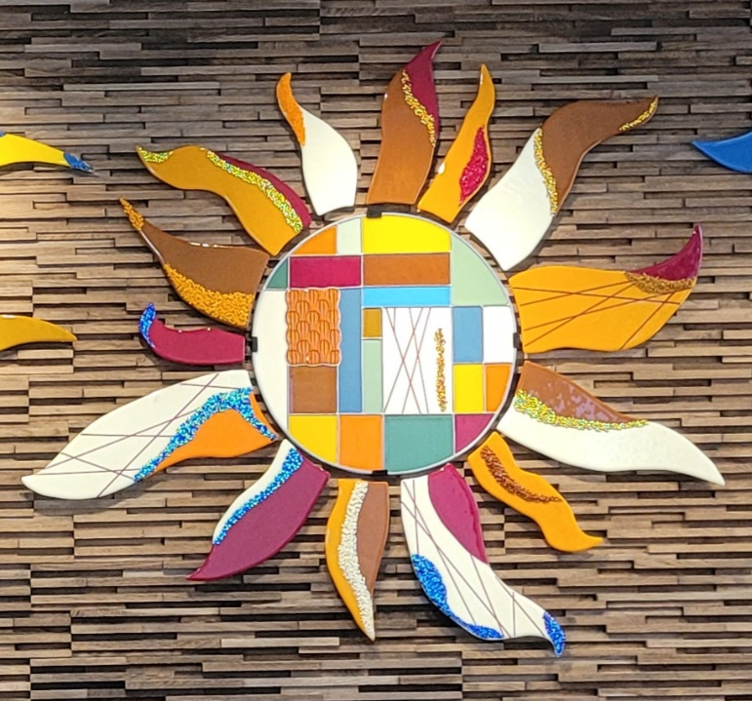

Glass Arts Club
Newsletter

March 2026

Congratulations
to the our newly-elected Board

President: Douglas Smith
Vice President: Ted Fainberg
Secretary: Kristi Williams
Treasurer: Jennie Ford

They will assume their positions beginning March 1st.

Given the short transition time, the retiring board will be helping the new board members take on their roles and responsibilities over the next couple of months.

March Highlights

- March Display Case: Awards from the 2025 and 2026 Riverside County Fair and Date Festival will be presented in the cabinet this month.

- March Arts & Craft Show—March 27 and 28: We have a dozen sellers who will be showing their fabulous glass artwork at this show. Flyers with QR codes for club entry are available to give out to friends and family. We need everyone to publicize this event as there will not be a large-scale advertising effort beyond posting it on Eventbrite. Currently, Dan Randles and Irma Lopez of the HOA staff are overseeing this show while actively searching for one or more members of the community to volunteer to run future shows, beginning with next November’s Holiday Show. Also, both Lori Fischer and JoAnn Effron are resigning their responsibilities for organizing these bi-annual shows for the club, so if Glass Arts wants to continue participating, we need some volunteers to take it on. Contact Lori (lorifischer@ymail.com) and JoAnn (joann@effron.com) for information about what’s involved.

- Field Trip to CBS (Coatings By Sandberg): We are working with CBS, a dichroic glass manufacturer, to schedule a club field trip to include a tour of their manufacturing process and dedicated sale for club members. With a minimum of 10 members, the company has graciously offered an exclusive sale on many of their products, such as full disks, scrap packages, stringers and frit. More information to follow as specifics are finalized.

- Website: Sue King, the club’s Web Editor, has created a new and exciting website for us with photos of both stained and fused glass artwork. However, we need more photos of fused glass and Diane Spiegel has offered to take photos and will let members know of her availability in the coming months.

- Firing Reminders:

  - Firing Schedule prior to the Arts & Craft Show—The last firing will be on Wednesday, March 25th, and all pieces left on the wire shelves must be removed by Thursday morning, March 26th, so the studio can be cleaned and prepped for the Craft Show. Anything left on the wire shelves and back counters will be stored elsewhere during the show.

  - Firing Issues and Problems—If you have any concerns about a fired piece, contact Liz Young at iblizy3@aol.com or NaDean Krasnove at nadeankras@gmail.com, preferably with “before and after” photos.

Education Calendar for March

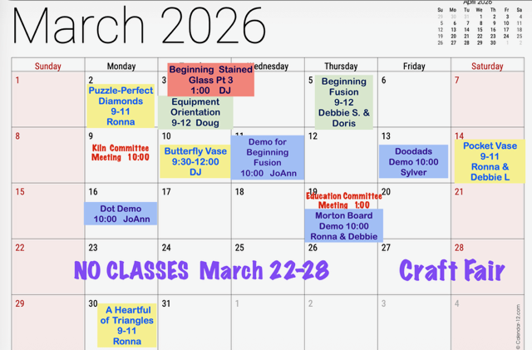

- The Glass Arts room will be closed Monday, March 9th, from 10 to 11am, for a Kiln Committee Meeting.

- Some classes may require the studio to be closed when in session, which is the case for the Beginning Fusion Classes and other classes with the maximum number of students. So, check the calendar before heading to the studio as you may be turned away. Occasionally, the teacher may make an exception if it’s a small class. In that case the teacher may allow others to work quietly during the class but you will not be able to use a grinder until class is over.

Store Hours for March

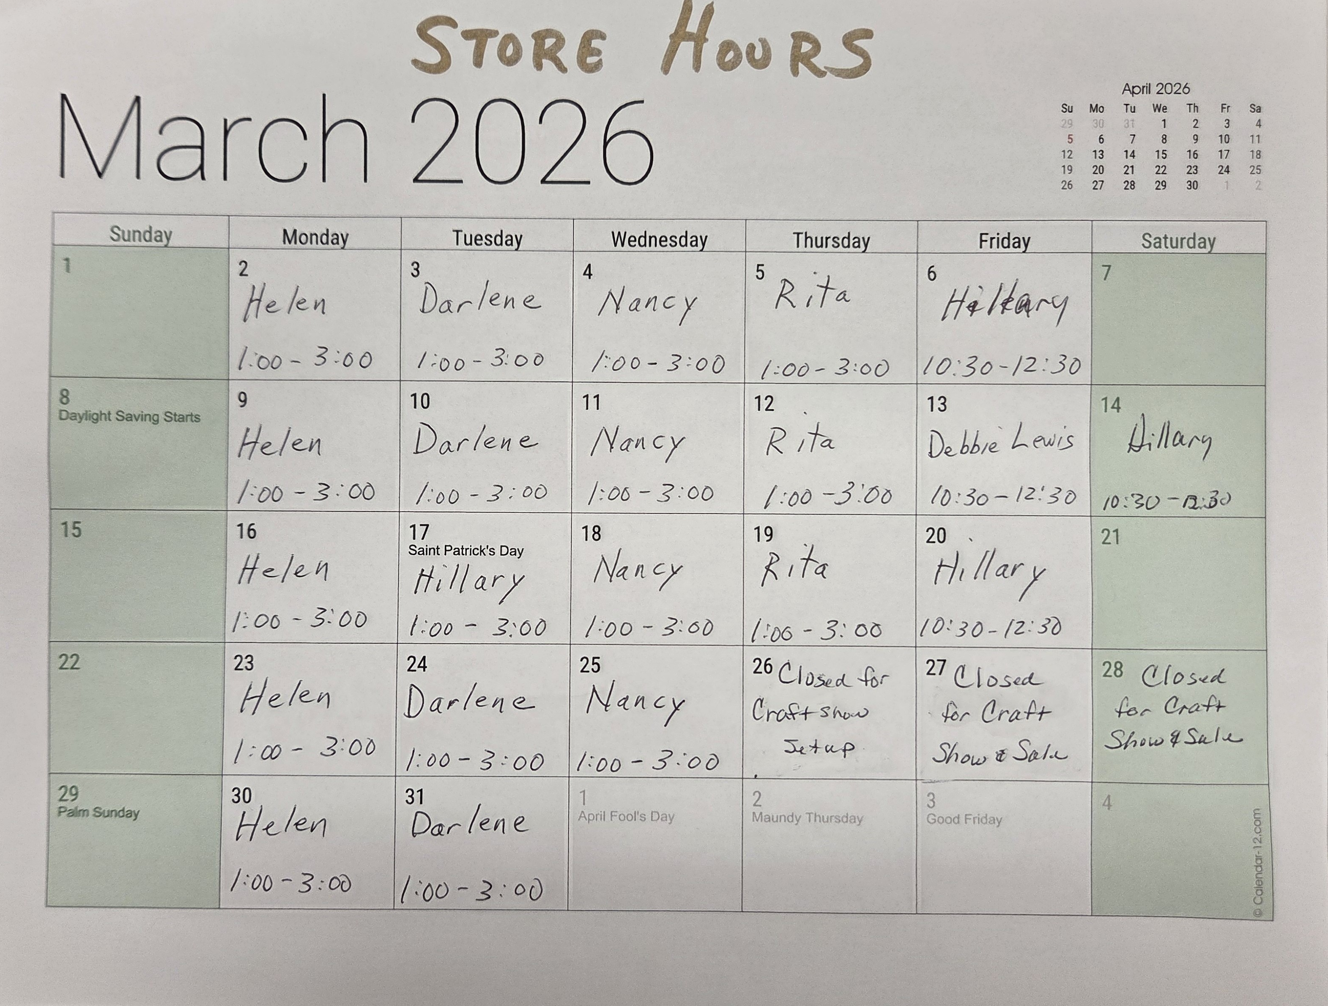

- There will be no Store Hours from Thursday, March 26th, through Saturday, March 28th due to the Arts & Craft Show.

Our Volunteers
Committees
Education Committee Chair: Debbie Lewis -- bryjak24@yahoo.com

Inventory Committee Chair: Julie Sribney – jsribney@gmail.com
Nancy Solomon -- nancysolomon26@gmail.com
Storekeepers: Helen Nielsen – helennielsen@msn.com

Kiln Committee Co-Chairs: NaDean Krasnove – nadeankras@gmail.com &
Liz Young -- iblizy3@aol.com

Display Case: DJ Miles -- djmiles1955@gmail.com &
Sylver Kinsella – inkstone2@gmail.com

Library: Diane Boger – diane.boger@gmail.com

News & Views: Carol Bishop – crlbishop9@gmail.com

Safety: Donna Du Fresne – fresnefamily@gmail.com

Social Events: Sylver Kinsella – inkstone2@gmail.com

Arts & Craft Show: Lori Fischer - lorifischer@ymail.com &
JoAnn Effron – joann@effron.com

Web Editor: Sue King – sking0730@gmail.com

Board
President: Doug Smith – dsmith@caltech.edu

Vice President: Ted Fainberg - tedfainberg@gmail.com

Secretary: Kristi Williams - kristiw1969@yahoo.com

Treasurer: Jennie Ford – JTFord88@aol.com

