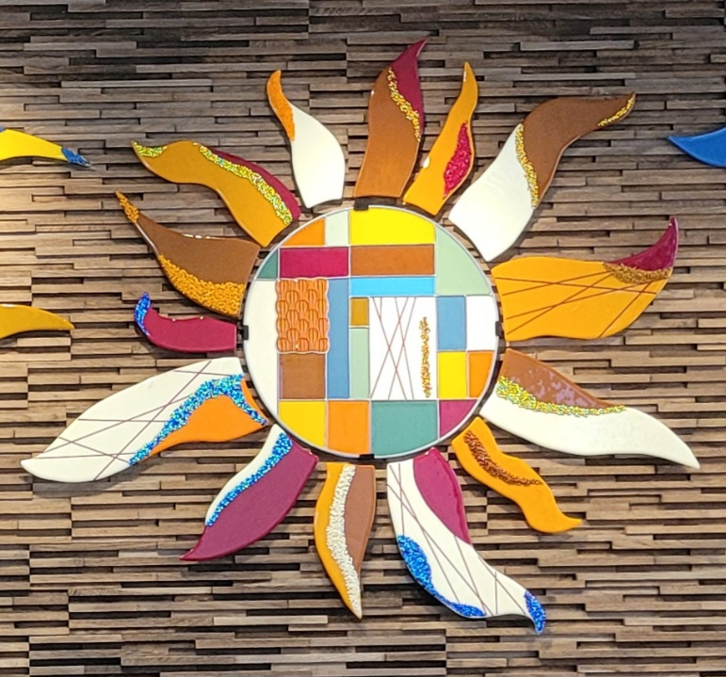

Glass Arts Club
Newsletter

January 2026

Your Club STILL NEEDS YOUR HELP!
It’s time to decide to join the club’s Board and submit your name as a nominee for one of the 5 Board positions. A summary of responsibilities for each of the 5 positions is posted around the studio. Detailed descriptions for each position are in the white binder labeled “Nominations…” which is on the Administration counter. If you enjoy the benefits you get from the Glass Arts club, then support our club by joining the Board.
Unless a full Board is elected next February, Glass Arts Club will lose its status as a Chartered Club and be dissolved and we will lose the use of the room and kilns as a result.
Surely, you want to see the club continue and are willing to give your time to one of these board positions: President, Co-President, Vice President, Secretary and Treasurer. SO…
- Meet with a current board member to discuss what they do. Their email addresses are listed at the end of this newsletter.
- Review the Roles and Responsibilities of each position in the Nominations Binder
- Contact a member of the Nominations & Elections Committee for additional questions:
  - Nancy Solomon (nancysolomon26@gmail.com)
  - NaDean Krasnove (nadeankras@gmail.com)
- Then fill out a nominations form, either for yourself or to nominate someone else whom you feel would be a good fit for a Board position, and put it in the suggestion box in the hall next to the studio door.
Help shape the future of Glass Arts!

January Highlights

- It’s time to renew your club membership. If you haven’t already done so, stop by the studio during store hours to fill out a form and pay your fees. Tear off and read the Operating Rules then sign the Acknowledgement Form on the back of the Membership Form before turning it in to the storekeeper with your check or cash.
The renewal period ends on January 31st. If you have a locker and only use it for storage OR don’t plan on renewing, please clean it out now and return the key during store hours to receive your $10 deposit. We have a long waiting list for lockers, especially for those who regularly work in the studio. Be considerate of those who have to shuttle their supplies back and forth to the studio, sometimes daily.

- The Board appointed Betsy Polousky as the club Secretary. She will fill that job until our elections in February. Thank you, Betsy, for once again taking on that role.

- We need photos of your fused glass artwork for the website. Sue King, our Web Editor, has been recreating our website and is asking for photos of glass fusion pieces in either JPEG or PNG format. They should be hi-resolution at least 72 Pixels per inch. Contact her at sking0730@gmail.com for more information.

- Charity Suggestions. We are asking for suggestions of local charities that we could offer donations to each year. In the past we have given donations to the Children’s Discovery Museum in Rancho Mirage. If you have another favorite local charity, preferably one related to the creative arts, please let us know by putting your suggestion in the box outside our room.

- Consider showing your glass artwork at The Riverside County Fair and Date Festival. The fair is held annually in February in Indio and January 19th is the final day to submit your entry registration.

- The Spring Arts & Craft Show will be discussed with club presidents and representatives on January 9th. This will be the first meeting since the entire Show Committee resigned following the November Show. Stay tuned for more information about the March Show & Sale.

- NEW Requirement for making DOTS: There have been too many people using multiple tiles for dots at one time. You are now limited to using no more than 2 tiles of dots for firing at the same time. Once those have been fired you may use up to 2 more tiles.

Fusing Reminders

- Speaking of Making DOTS
  - There will be a Demo about making Dots on Jan. 13th at 10am
  - Use only the 5x5 or 6x6 tiles and use only 2 tiles at one time.
  - Cut scrap kiln paper to fit your tile and use a drop of glue to hold the cut paper together on the tile
  - List or describe the colors and give a count of them or the number of rows on your firing slip or they will not be fired.
  - Write your name in metallic ink on the paper so that the people unloading the kiln can match the fired dots to the correct firing slip.

- When to Use Tiles
  - for DOTS (see above)
  - for fragile pieces that need solid support; anything that can be moved to the kiln in one piece does not need to be on a tile.

- ALWAYS clean your glass before placing it on the shelves for firing, especially before putting your piece in for the next firing. There may be residue from the kiln paper after its previous firing.

- ALWAYS clean your basket both inside and outside, then dry it and put it back on the stack. DO NOT LEAVE IT IN THE SINK for someone else to dry and put back on the stack. AND CLEAN UP RESIDUE FROM THE SINK BEFORE YOU LEAVE.

- If you encounter any issues with a fired project, reach out to NaDean at 310-993-7976 or Liz at 760-409-8181 preferably with “before & after” pictures.

EACH COLOR OF GLASS IS UNIQUE AND MAY MELT AT A DIFFERENT TEMPERATURE AND SPEED FROM OTHER COLORS, EVEN WITHIN THE SAME COE RATING. THICKER PIECES MAY NOT COME OUT AS EXPECTED AND MAY CRACK WHEN SLUMPED IN DEEP MOLDS OR ON MOLDS WITH DEEP CURVES. LIMIT YOUR PIECES TO 3 LAYERS TO BE SAFE FROM CRACKING OR BREAKING WHEN SLUMPED.

Education Calendar for January

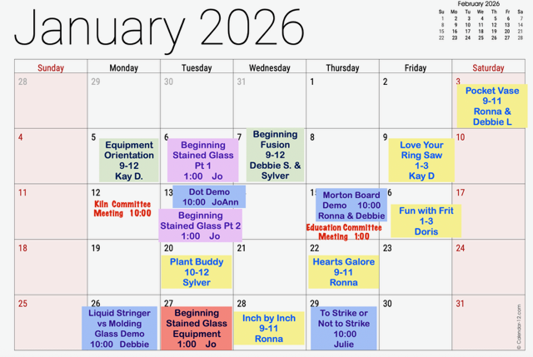

Note that the Glass Arts room will be closed Monday, January 12th from 10 to 11am, for a Kiln Committee Meeting.

Store Hours for January

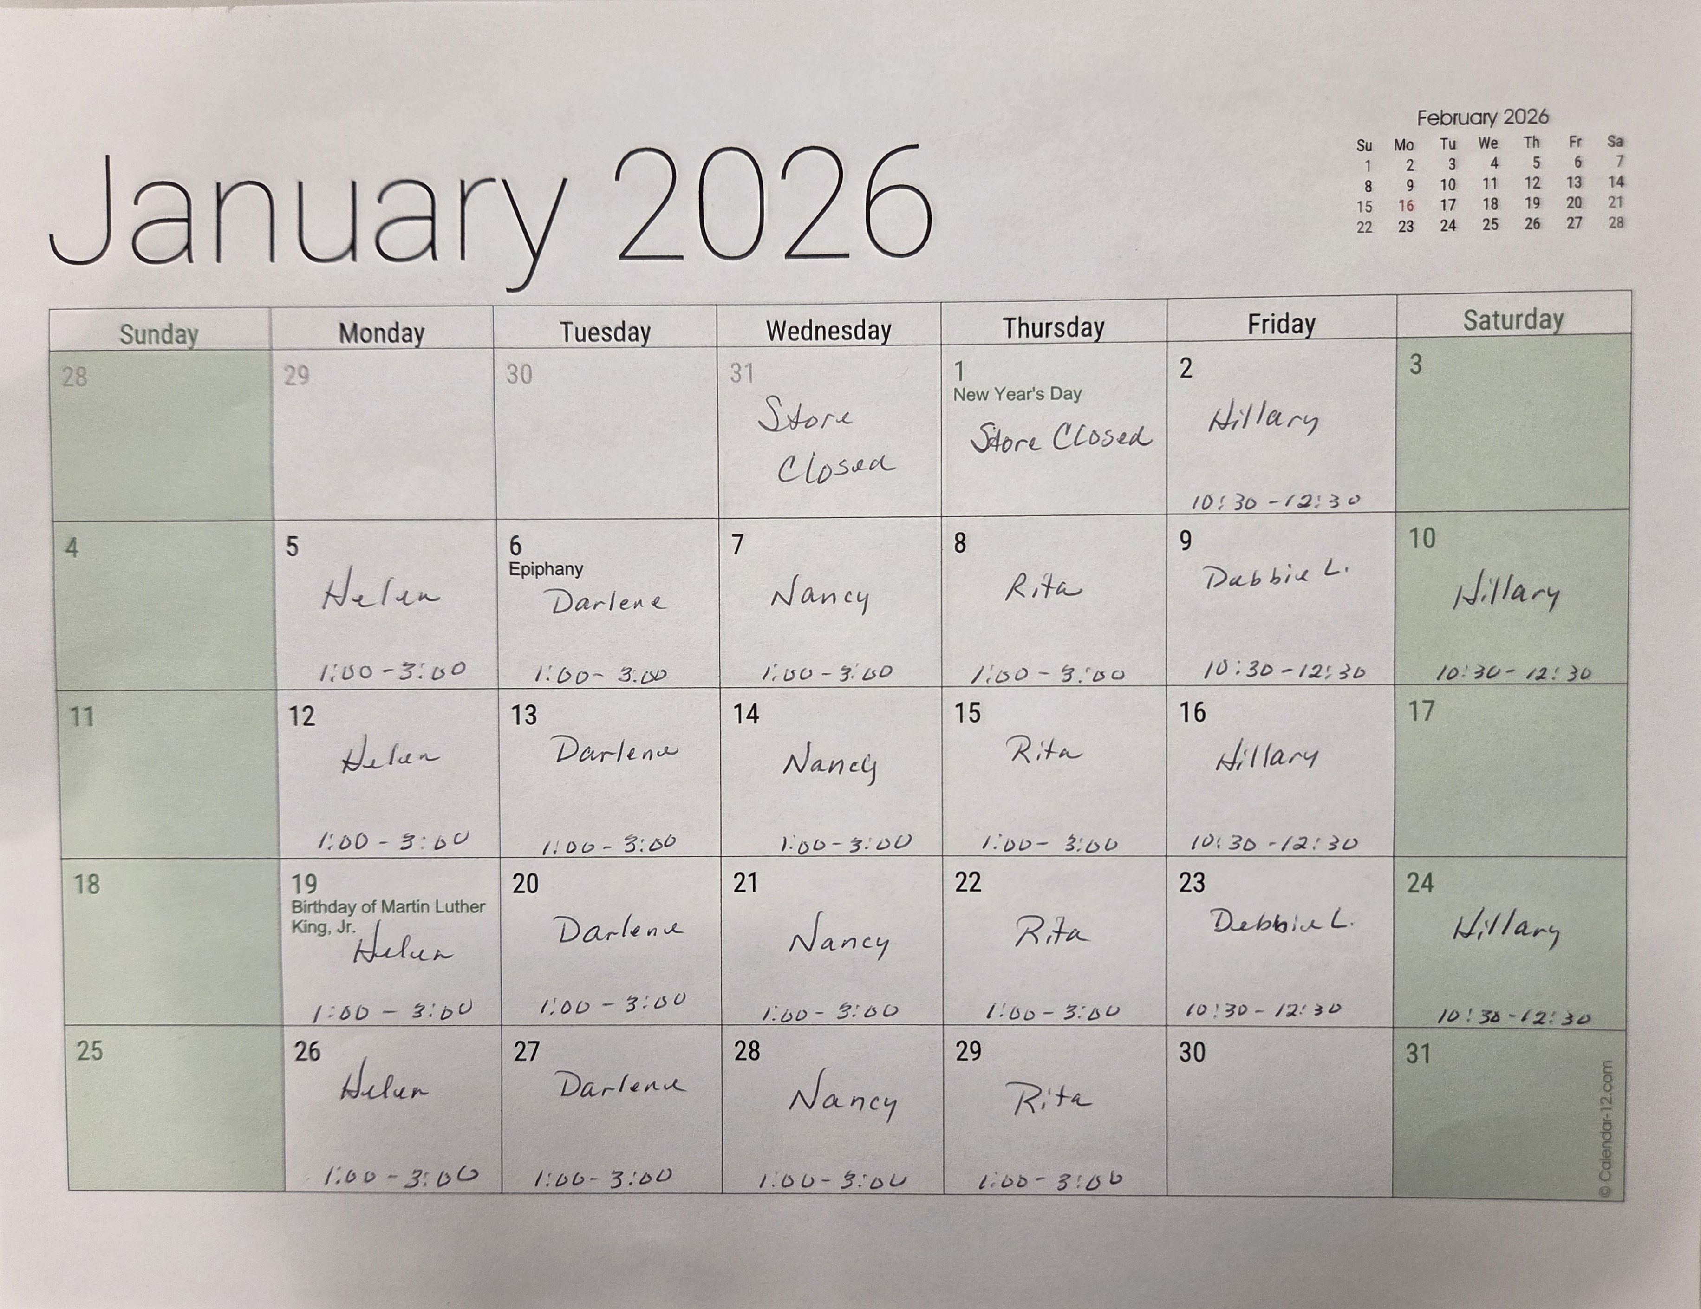

Our Volunteers
Committees
Education Committee Chair: Debbie Lewis -- bryjak24@yahoo.com

Inventory Committee Chair: Julie Sribney – jsribney@gmail.com
Nancy Solomon -- nancysolomon26@gmail.com
Storekeepers: Helen Nielsen – helennielsen@msn.com

Kiln Committee Co-Chairs: NaDean Krasnove – nadeankras@gmail.com &
Liz Young -- iblizy3@aol.com

Display Case: DJ Miles -- djmiles1955@gmail.com &
Sylver Kinsella – inkstone2@gmail.com

Library: Diane Boger – diane.boger@gmail.com

News & Views: Carol Bishop – crlbishop9@gmail.com

Safety: Donna Du Fresne – fresnefamily@gmail.com

Social Events: Sylver Kinsella – inkstone2@gmail.com

Arts & Craft Show: Lori Fischer - lorifischer@ymail.com &
JoAnn Effron – joann@effron.com

Web Editor: Sue King – sking0730@gmail.com

Board
President: JoAnn Effron – joann@effron.com

Co-President: Kay Denson – ktraildenson@gmail.com

Vice President: Doug Smith – dsmith@caltech.edu

Secretary: Betsy Polousky – ewp@owenpolousky.com

Treasurer: Veda Gilman – vedagilman@gmail.com

