

Glass Arts Club
Newsletter

February 2026

General Meeting and Club Elections
February 20th from 2 to 4 pm
Idyllwild – Saddleback rooms
Join us for a fun and informative meeting and the election of the following nominees for club officers:
President: Douglas Smith
Vice President: Ted Fainberg
Secretary: Kristi Williams
Treasurer. Jennie Ford
There will be a social following the meeting to welcome our new board members.
As always, we need a quorum to conduct the meeting and election, so this means all local members are encouraged to attend.
There is currently no nominee for Co-President and we continue to search for a candidate to assume the club presidency during the summer when the President is away. This position must be filled by a full-time SCPD resident. If you are interested in nominating yourself or someone else, there is still time to submit your nomination form by contacting:
Nancy Solomon at 805-427-0368 or nancysolomon26@gmail.com.

February Highlights

- The next Beginning Stained Glass Class will start on Feb. 17th. It will continue for 3 successive weeks on Tuesday, Feb. 24th and Tuesday, March 3rd. Sign up during store hours. This will be the last class of this type for the near term.

- Have you Renewed your Membership? If you haven’t already done so, stop by the studio during store hours to fill out a form and pay your fees by February 28th. Otherwise, if you have a locker and don’t renew your membership, you need to clean out your locker as soon as possible or the contents will become the property of the club.

- We are still in need of lockers for active members. As a renewing member, if you have a locker and don’t regularly use or need it, please clean it out and return the key during store hours to receive your $10 deposit. We have a long waiting list for lockers, especially for those who regularly work in the studio. Be considerate of those who have to shuttle their supplies back and forth to the studio, sometimes daily.

- Riverside County Fair and Date Festival. A few members have submitted their glass artwork at this year’s fair which is being held in Indio from February 12th through March 1st. If you aren’t able to get to the fair, we will be showing our award-winning entries from both 2025 and 2026 in the display case during March.

- Charity Suggestions. We are asking for suggestions of local charities that we could offer donations to each year. In the past we have given donations to the Children’s Discovery Museum in Rancho Mirage. If you have another favorite local charity, preferably one related to the creative arts, please let us know by putting your suggestion in the box outside our room.

- Volunteering Opportunities: Thanks to those of you who have indicated an interest in helping with our various committees and activities. Your names have been sent to the appropriate parties and you will be contacted when help is needed.

Fusing Reminders

- EACH PROJECT NEEDS A SEPARATE FIRING SLIP AND SEPARATE ENTRY LINE IN THE PURPLE BOOK, even when more than one project is placed in a basket or on a board for firing.

- DO NOT USE BASKETS TO STORE WORK IN PROGRESS. They are not to be put in your locker or brought home. They are only to be used for placing your fusion projects on the firing shelves. And…

- ALWAYS CLEAN YOUR BASKET INSIDE AND OUT, then dry it and put it back on the stack when you’re done with it. DO NOT LEAVE IT IN THE SINK for someone else to dry and put back on the stack. AND CLEAN UP RESIDUE LEFT IN THE SINK BEFORE YOU LEAVE. WE SHOULD NOT BE CLOGGING UP THE SINKS.

- Requirements for making DOTS:
  - You are limited to using no more than 2 tiles of dots for firing at the same time. Once those have been fired you may use up to 2 more tiles.
  - Use only the 5x5 or 6x6 tiles that are set aside on the open shelves
  - Cut scrap kiln paper to fit your tile and use a drop of glue to hold the cut paper together on the tile
  - Write your name in metallic ink on the paper so that the people unloading the kiln can match the fired dots to the correct firing slip
  - List or describe the colors and give a count of them or the number of rows on your firing slip or they will not be fired.

- When to Use Tiles
  - for DOTS (see above)
  - for fragile pieces that need solid support; anything that can be moved to the kiln in one piece does not need to be on a tile.

- If you encounter any issues with a fired project, reach out to NaDean at 310-993-7976 or Liz at 760-409-8181, preferably with “before & after” pictures.

Education Calendar for February

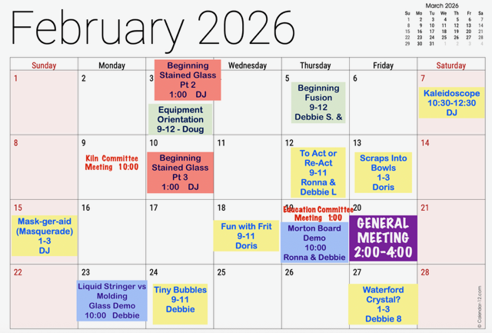

- The Glass Arts room will be closed Monday, February 9th, from 10 to 11am, for a Kiln Committee Meeting and during the General Meeting and Election on Friday, February 20th, from 2 to 4pm.

- Some classes may require the studio to be closed when in session, which is often the case for the Beginning Fusion Classes and other classes with the maximum number of students. So, check the calendar before heading to the studio as you may be turned away. Occasionally, the teacher may make an exception if it’s a small class. In that case the teacher may allow others to work quietly during the class but you will not be able to use a grinder until class is over.

Store Hours for February

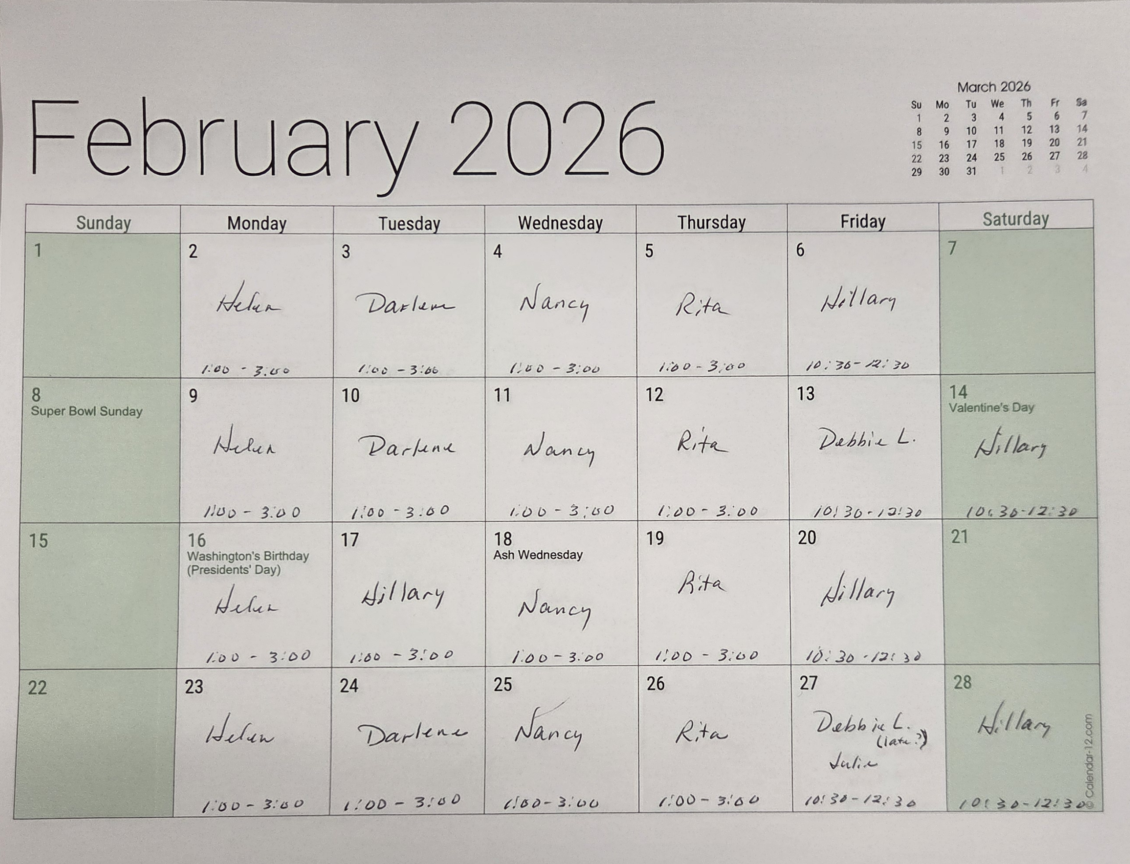

Our Volunteers
Committees
Education Committee Chair: Debbie Lewis -- bryjak24@yahoo.com

Inventory Committee Chair: Julie Sribney – jsribney@gmail.com
Nancy Solomon -- nancysolomon26@gmail.com
Storekeepers: Helen Nielsen – helennielsen@msn.com

Kiln Committee Co-Chairs: NaDean Krasnove – nadeankras@gmail.com &
Liz Young -- iblizy3@aol.com

Display Case: DJ Miles -- djmiles1955@gmail.com &
Sylver Kinsella – inkstone2@gmail.com

Library: Diane Boger – diane.boger@gmail.com

News & Views: Carol Bishop – crlbishop9@gmail.com

Safety: Donna Du Fresne – fresnefamily@gmail.com

Social Events: Sylver Kinsella – inkstone2@gmail.com

Arts & Craft Show: Lori Fischer - lorifischer@ymail.com &
JoAnn Effron – joann@effron.com

Web Editor: Sue King – sking0730@gmail.com

Board
President: JoAnn Effron – joann@effron.com

Co-President: Kay Denson – ktraildenson@gmail.com

Vice President: Doug Smith – dsmith@caltech.edu

Secretary: Betsy Polousky – ewp@owenpolousky.com

Treasurer: Veda Gilman – vedagilman@gmail.com

