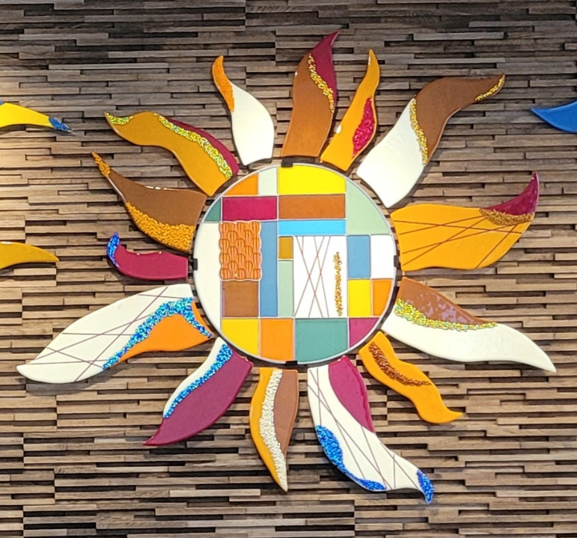

Glass Arts Club
Newsletter

December 2025

Your Club Needs YOU!
This is the season of giving and it is time to think seriously of giving back to your club that continues to provide its members with a wealth of opportunities to express themselves so creatively. As reported at our recent General Meeting, none of the current board members will be returning to their current positions though at least one of the current members may choose to run for a different position. That means the club needs more of its members to step up to help guide the club's future. This is an unprecedented situation for such a thriving and growing group and unless a full board is elected next February, Glass Arts Club will lose its status as a Chartered Club and be in danger of losing its use of the room as a result.
Surely there are some of you who want to see the club continue and are willing to give your time to one of these board positions: President, Co-President, Vice President, Secretary and Treasurer. SO…
- Join us at the next board meeting on Wednesday, December 10th at 11am at Kay Denson’s home and see what goes on.
- Meet with a current board member to discuss what they do. Their email addresses are listed at the end of the newsletter.
- Review the Roles and Responsibilities of each position.
- Contact a member of the Nominations & Elections Committee for additional questions:
  - Nancy Solomon (nancysolomon26@gmail.com)
  - Vicki Vogl (vjvogl10@gmail.com)
  - NaDean Krasnove (nadeankras@gmail.com)
Take an active role in our survival and help shape the future of Glass Arts!

What’s New for December

- It’s time to renew your club membership. Stop by the studio during store hours to fill out a form and pay your fees. Also tear off and read the Operating Rules then sign the Acknowledgement Form on the back of the Membership Form before turning it in to the storekeeper. The renewal period ends on January 31st but if you don’t plan on renewing and have a locker, please clean out your locker and return the key during store hours to receive your $10 deposit.

- Bring pieces for the Display Case Saturday, December 6th. We will be adding to what’s already there, so share more of your holiday pieces, including something from the Arts & Craft Show.

- Debbie & Doug Smith are hosting a Glass Arts Holiday Party on December 15th. It’s a potluck with a gift exchange which offers some joyful fun. See the fliers posted in the studio. Parking is extremely limited on Rainbow Ave. so carpool or take your golf cart.

- We need photos of your glass artwork for the website. Sue King, our Web Editor, is asking for photos in either JPEG or PNG format. They should be hi-resolution at least 72 Pixels per inch. Contact her at sking0730@gmail.com for more information.

- Consider showing your glass artwork at The Riverside County Fair and Date Festival. The fair is held annually in February so now is the time to start working on some special projects to display at the fair and compete for prizes.

Fusing Reminders

- When to use a tile:
  - for DOTS (5x5 and 6x6 tiles only)
  - for fragile pieces that need solid support; anything that can be moved to the kiln in one piece does not need to be on a tile.

- Speaking of DOTS:
  - You must list or describe the colors (and a count of them when practical) on your firing slip or they will not be fired.
  - Cut scrap kiln paper to fit your tile and use a single drop of glue to hold the paper on the tile.
  - Write your name in metallic ink on the paper so that the people unloading the kiln can match the fired dots to the correct firing slip.

- ALWAYS clean your glass before placing it on the shelves for firing, including before putting your piece in for slumping. There may be residue from the kiln paper after its previous firing.

- ALWAYS clean your basket both inside and outside. DO NOT leave it in the sink for someone else to dry and put back on the stack.

- If you encounter any issues with a fired project, reach out to NaDean at 310-993-7976 or Liz at 760-409-8181 preferably with a picture.

EACH COLOR OF GLASS IS UNIQUE AND MAY MELT AT A DIFFERENT TEMPERATURE AND SPEED FROM OTHER COLORS, EVEN WITHIN THE SAME COE RATING. THICKER PIECES MAY NOT COME OUT AS EXPECTED AND MAY CRACK WHEN SLUMPED IN DEEP MOLDS.
REMEMBER, THE KILN WILL DO WHAT IT WANTS TO DO

Education Calendar for December

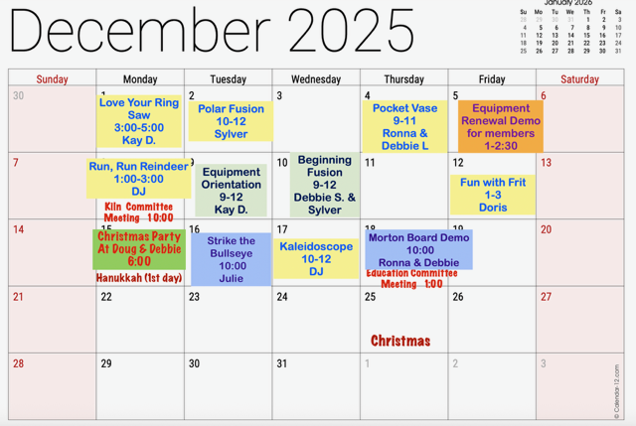

Note that the Glass Arts room will be closed Monday, December 15th from 10 to 11am for a Kiln committee Meeting.

Store Hours for December

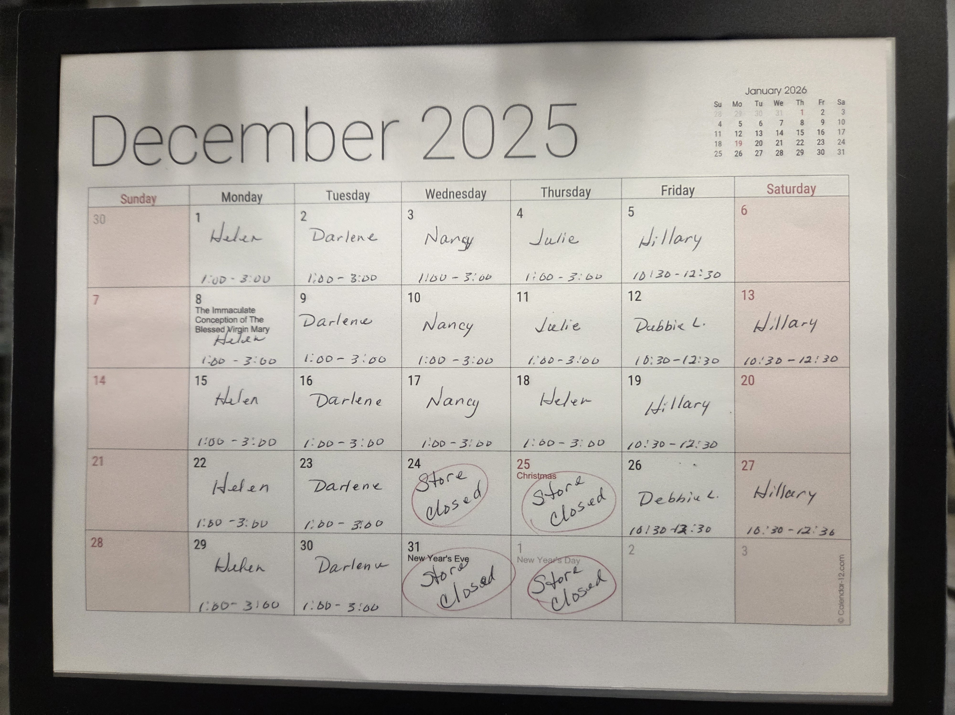

Note that the store will be closed on 12/24 & 12/25 for Christmas and on 12/31 & 1/1/2026 for New Years.

Our Volunteers
Committees
Education Committee Chair: Debbie Lewis -- bryjak24@yahoo.com

Inventory Committee Chair: Julie Sribney – jsribney@gmail.com
Nancy Solomon -- nancysolomon26@gmail.com
Storekeepers: Helen Nielsen – helennielsen@msn.com

Kiln Committee Co-Chairs: NaDean Krasnove – nadeankras@gmail.com &
Liz Young -- iblizy3@aol.com

Display Case: DJ Miles - djmiles1955@gmail.com &
Sylver Kinsella – inkstone2@gmail.com

Library: Diane Boger – diane.boger@gmail.com

News & Views: Carol Bishop – crlbishop9@gmail.com

Safety: Donna Du Fresne – fresnefamily@gmail.com

Social Events: Sylver Kinsella – inkstone2@gmail.com

Arts & Craft Show: Lori Fischer - lorifischer@ymail.com &
JoAnn Effron – joann@effron.com

Web Editor: Sue King – sking0730@gmail.com

Board
President: JoAnn Effron – joann@effron.com

Co-President: Kay Denson – ktraildenson@gmail.com

Vice President: Doug Smith – dsmith@caltech.edu

Secretary: VACANT

Treasurer: Veda Gilman – vedagilman@gmail.com

