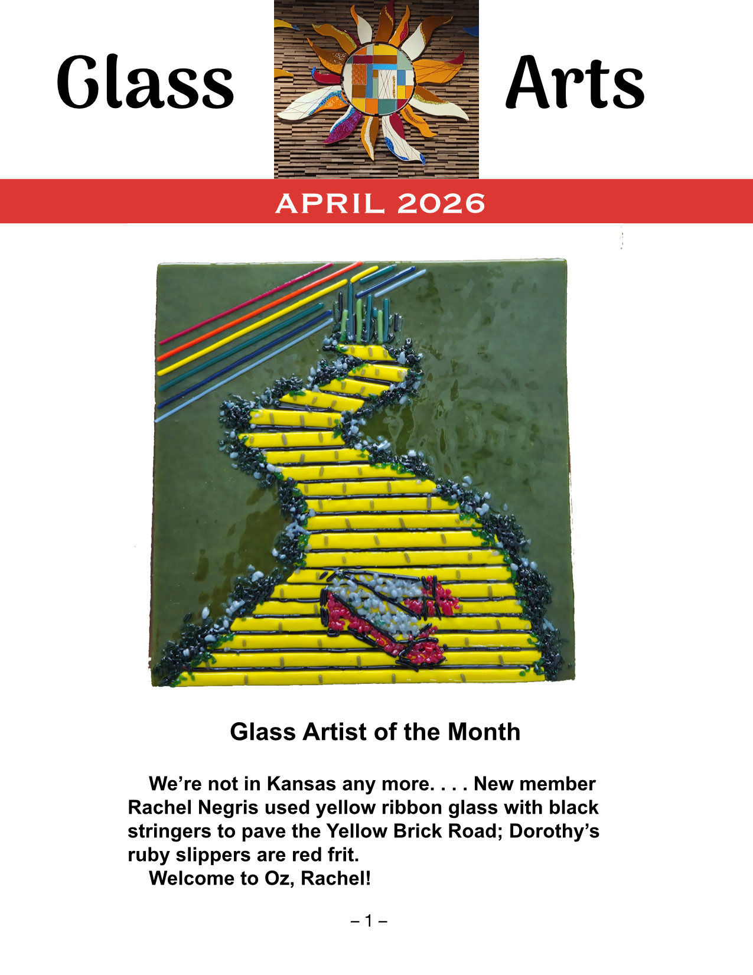
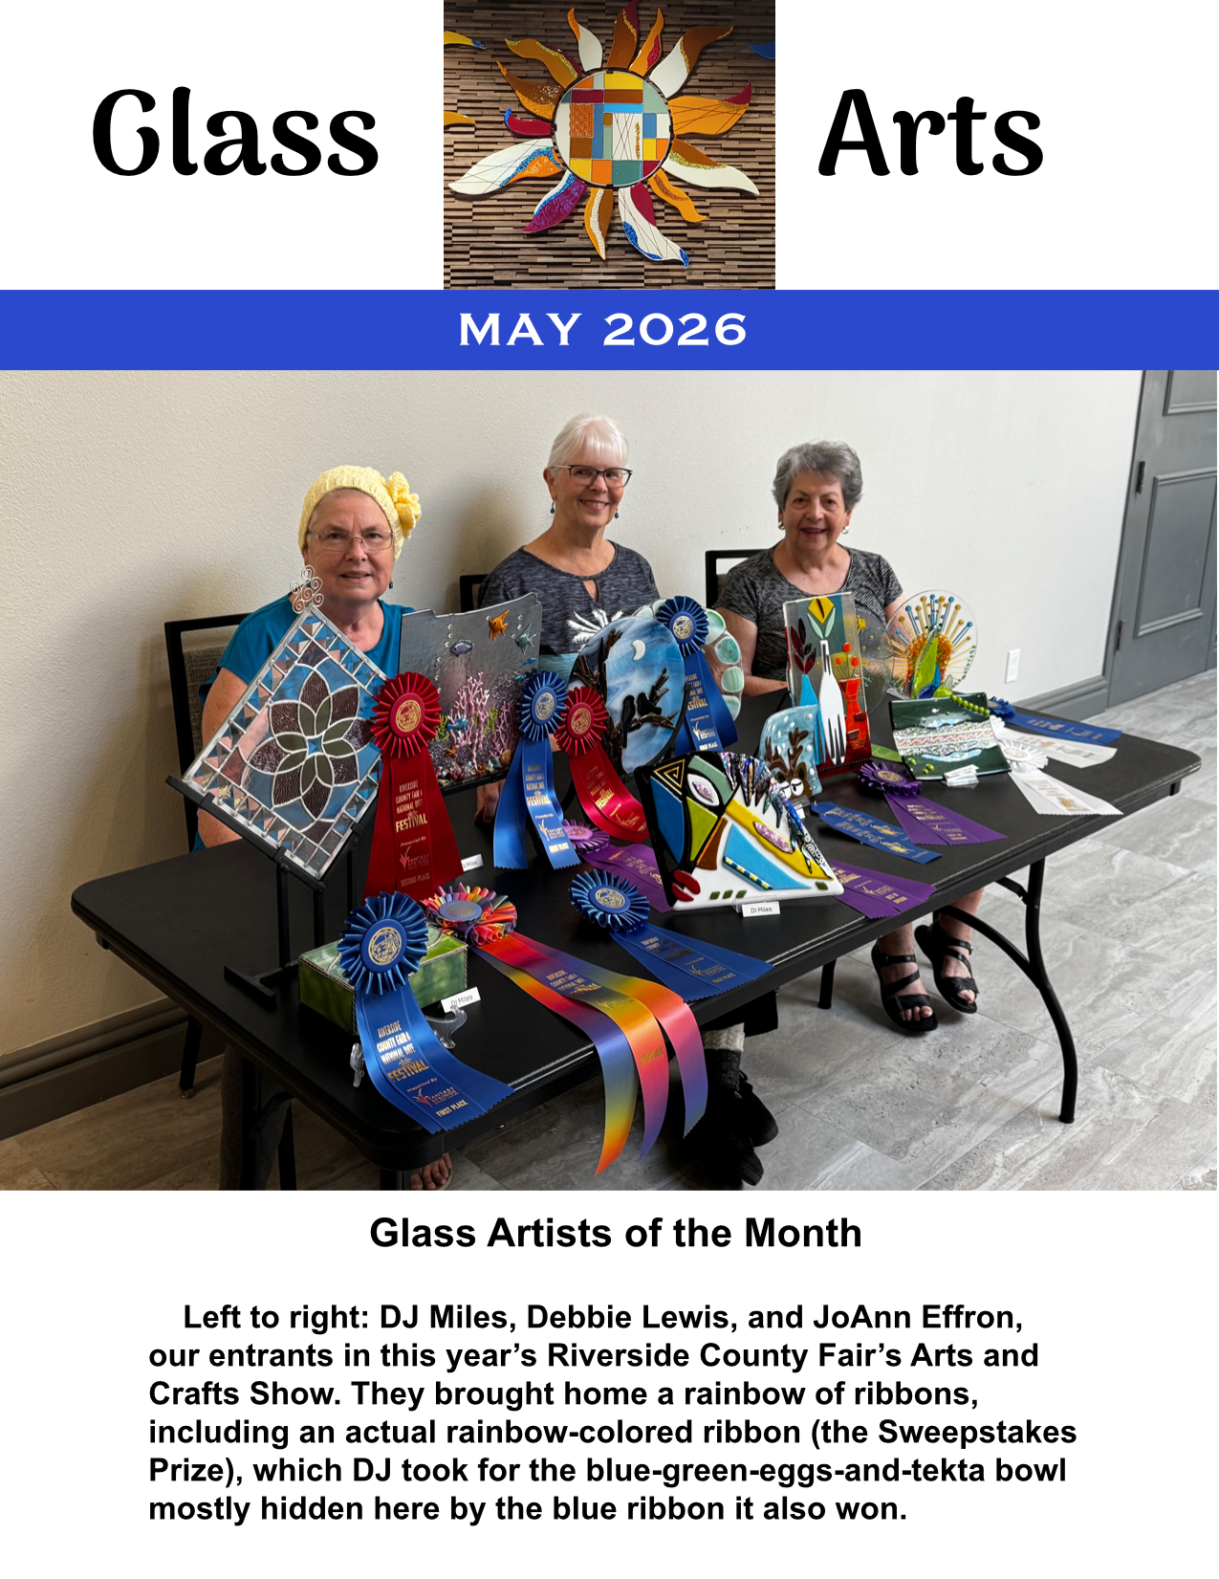
DOUGIE’S DODDERINGS:
HGTV (Hot Glass TV) Is On the Way!

As Variety would say, Lori Fischer is now helming HGTV's production department. She’s set volunteers from the Education and Kiln Committees aprowl on the internet for video clips to show, and a few folks have earned their broadcasters’ licenses on our equipment. We hope to have a critical mass of videos on file and people who know how to play them soon. Talk to Lori to get in on the ground floor of our budding media empire . . . there’s plenty of room at the bottom!

YOU CAN EXHALE NOW . . .
New Safety Co-Chairs Volunteer

Jennie Ford and Hillary Murphy have struck up the Band-Aid Brigade. Many thanks to outgoing chair Donna DuFresne for all her good work!

STUDIO FAILS, PART I:
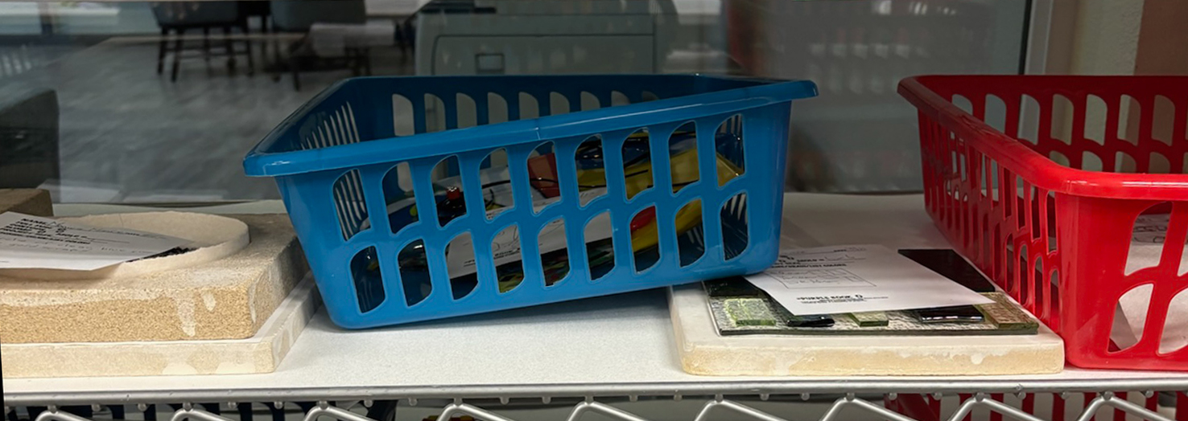
Please Don’t Do This!

SQUIBS FROM THE FIRING SQUAD:
Parking Restrictions Eased

Thank you all for decongesting the firing shelves. As a reward, the Firing Squad will now permit each member to have TWO projects of each type (full, contour, slump, and dot tiles) on the shelves at the same time. Pieces will continue to be fired in rotation, one per member, in the order in which they are logged in the Purple Book.

FUSING TIP O’ DA MONTH:
When the Levee Breaks

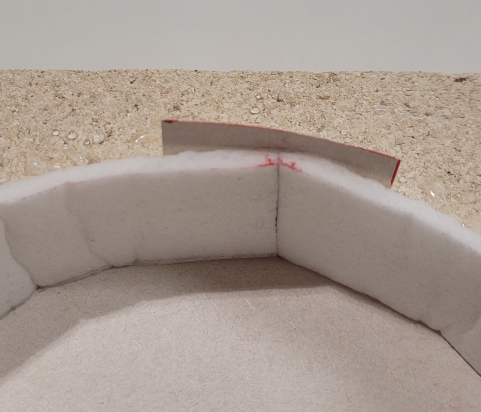
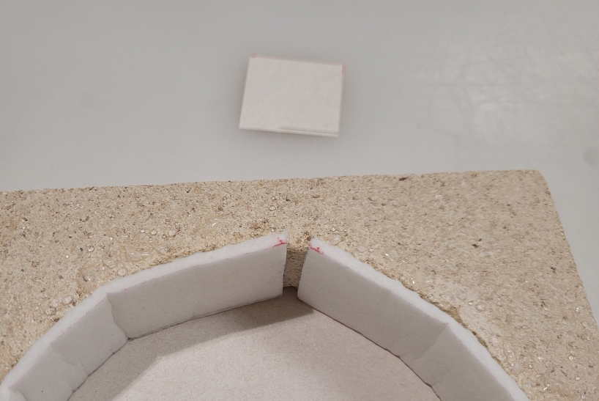
In “frit dam” projects (i.e., loose glass contained within fiber paper barriers), the molten glass can seep through the seams in the fiber paper and stick to the supporting structure behind. Putting a tab of kiln paper between the fiber paper and the support behind it will prevent the leak. Please use the scraps of kiln paper on Shelf F for this purpose.
THE CORNER STORE’S CORNER:
May Store Hours

MONDAYS – THURSDAYS: 1:00 P.M. – 3:00 P.M.
FRIDAYS: 10:30 A.M. – 12:30 P.M.
SATURDAY, MAY 9: 10:30 A.M. – 12:30 P.M.
SATURDAY, MAY 23: 10:30 A.M. – 12:30 P.M
CLOSED SUNDAYS

DISPLAY CASE CHANGEOUT:
Saturday, May 2: Plates & Bowls

You can leave your pieces on Shelf A in the studio beforehand, or drop them off in person at 9:30 a.m. on Saturday, May 2. Please make sure that your name is on each piece, as our Curators of the Cases are now making name tags for the display.

STUDIO FAILS, PART II:
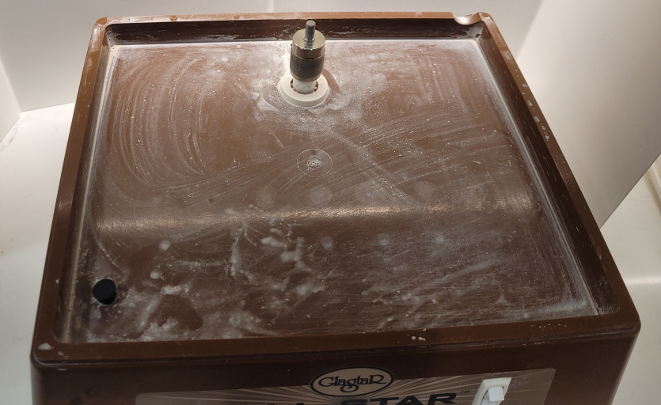
Rode Hard and Put Away Dirty
Board
President: Doug Smith – dsmith@caltech.edu
Co-President: Hillary Murphy – norahill2002@yahoo.com
Vice President: Ted Fainberg – tedfainberg@gmail.com
Secretary: Kristi Williams – kristiw1969@yahoo.com
Treasurer: Jennie Ford – jtford88@aol.com

Committee Chairs:

Arts & Craft Show: Jennie Ford – jtford88@aol.com &
Kristi Williams – kristiw1969@yahoo.com
Display Case: DJ Miles – djmiles1955@gmail.com &
Sylver Kinsella – inkstone2@gmail.com
Education: Debbie Lewis – bryjak24@yahoo.com
Inventory: Julie Sribney – jsribney@gmail.com
Nancy Solomon – nancysolomon26@gmail.com
Storekeepers: Helen Nielsen – helennielsen@msn.com
Kiln: NaDean Krasnove – nadeankras@gmail.com &
Liz Young – iblizy3@aol.com
Library: Diane Boger – diane.boger@gmail.com
News & Views: Carol Bishop – crlbishop9@gmail.com
Safety: Jennie Ford – jtford88@aol.com &
Hillary Murphy – norahill2002@yahoo.com
Social Events: Sylver Kinsella – inkstone2@gmail.com
Web Editor: Sue King – sking0730@gmail.com

